**Sales Performance Analysis Report**

Name : Ashwini Choudhary

Education: BTech(Computer Science)

Course: Business Analyst

Batch code: CX-96

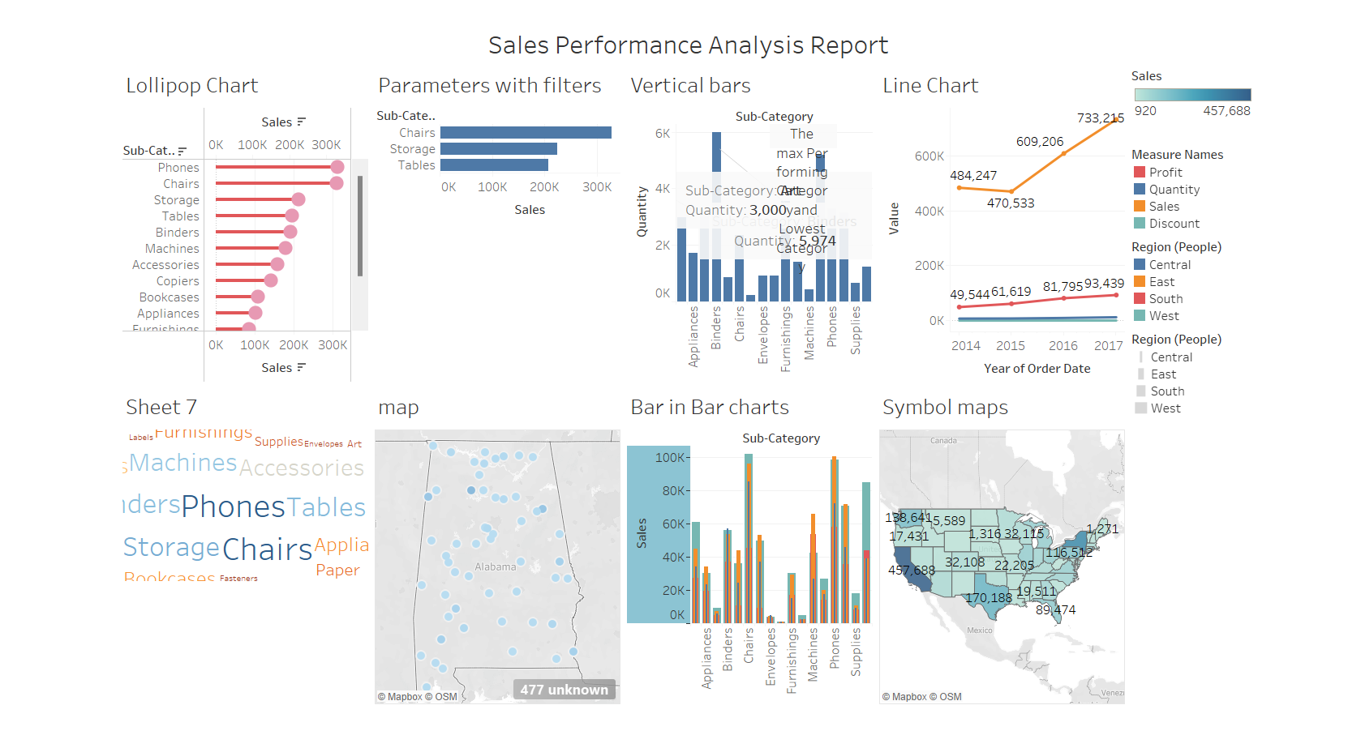

**1. Introduction**

This report presents an analysis of sales performance using data from the Sample Super Store. The objective is to gain insights into sales trends, identify key factors impacting sales, and provide recommendations for improving overall performance.

**2. Methodology**

The analysis is conducted using historical sales data from the Sample Super Store. Various statistical and visualization techniques are employed to explore and interpret the data.

**3. Requirement Analysis**

Key Objectives:

• Identify top-selling products and categories.

• Analyze sales trends over time.

• Evaluate sales performance across different regions.

• Identify factors influencing sales, such as discounts and shipping costs.

**4. Other Parameters**

Parameters Analyzed:

• Product categories

• Sales by region

• Profit margins

• Discounts and promotions

**5. Visualization**

Charts and Dashboards:

1. Sales Trend Over Time: Line chart showing monthly sales trends.

2. Top Selling Products: Bar chart displaying the top-selling products.

3. Sales by Region: Geographic map visualizing sales across different regions.

4. Profit Margin Analysis: Water fall chart illustrating profit margins for different product categories.

5. Discount Impact: Line chart showing the relationship between discounts, sales, quantity and profit volume.

**6. Insights**

Insights from Charts and Dashboards:

• Sales have been steadily increasing over the past year, with a noticeable spike in the holiday season.

• Furniture is the top-selling category, followed by Office Supplies and Technology.

• Sales are highest in the Western region, followed by the Eastern and Central regions.

• Despite high sales volume, the Furniture category has lower profit margins compared to Technology.

• Products with higher discounts tend to have higher sales volumes, indicating price sensitivity among customers.

**7. Conclusion**

In conclusion, the analysis reveals several key insights into sales performance at the Sample Super Store. To optimize performance, it is recommended to focus on maximizing sales in high-margin categories, optimizing pricing strategies to balance discounts with profitability, and targeting marketing efforts towards regions with lower sales volume. Additionally, ongoing monitoring and analysis of sales trends will be crucial for adapting to changing market dynamics and maintaining competitiveness.